Name : Md. Tasriful Hoque Mozumder

ID : CSE 06607652

Batch : CSE 66-A

Course Code : CSI 314

Course Title : Operating System Sessional

**Assignment 2**: Scheduling Algorithms

[This is Scheduling Algorithm implemented in python]

**First Come First Serve**

n = int (input("Enter no.of processess:"))

p = []

w = []

tw = 0

for i in range(n):

p.append(int (input("Enter process:")))

w.append(int (input("Enter weight:")))

d1 = dict(zip(p,w))

d2 = 0

weight = 0

print("Waiting time:")

for i, j in d1.items():

print (i,"=",weight)

d2 = d2 + weight

weight = weight + j

print("Average waiting time: ",d2/n)

for i in d1.values():

tw = tw + i

print("Average turn around time: ",(d2+tw)/n)

**Output:**

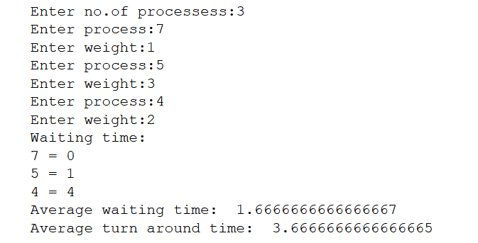

**Priority Scheduling**

print("*****No two processes must have same priority*****",end = "\n")

n = int (input("Enter no.of processess:"))

p = []

w = []

tw = 0

for i in range(n):

print("Process:",i,end="\n")

p.append(int (input("Enter priority:")))

w.append(int (input("Enter weight:")))

small = 9999

d1 = dict(zip(w,p))

d2 = dict()

for i in range(n):

small = 9999

for j in d1.keys():

if(d1[j] < small):

small = d1[j]

t = j

d1[t] = 9999

d2[t] = small

d1 = d2

d2 = dict()

for i , j in d1.items():

d2[j] = i

d1 = d2

d2 = 0

print(d1)

weight = 0

print("Waiting time:")

for i, j in d1.items():

print ("Process with ",i," priority has ",weight," waiting time")

d2 = d2 + weight

weight = weight + j

print("Average waiting time: ",d2/n)

for i in d1.values():

tw = tw + i

print("Average turn around time: ",(d2+tw)/n)

**Output:**

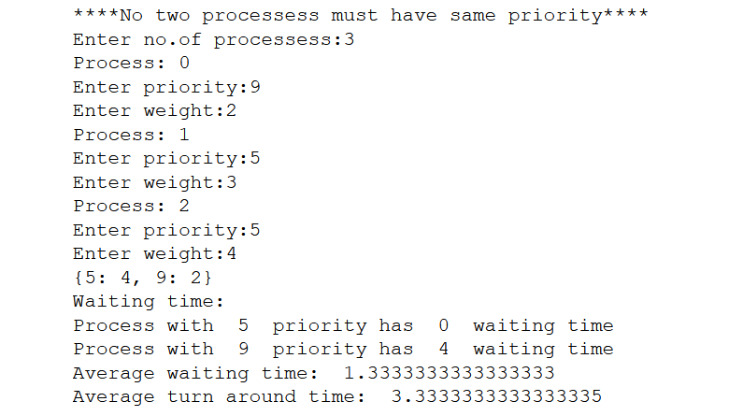

**Round Robin Scheduling**

n = int (input("Enter no.of processess:"))

q = int (input("Enter time quantum:"))

p = []

w = []

tw = 0

d2 = d3 = dict()

for i in range(n):

y = int (input("Enter process:"))

p.append(y)

j = int (input("Enter weight:"))

w.append(j)

tw = tw + j

d2[y] = 0

d1 = dict(zip(p,w))

d3 = dict(zip(p,w))

t = s = 0

#print(d1,d2,d3)

print("Waiting time:")

while(tw != 0):

for i in d1.keys():

if(d1[i] >= q):

tw = tw - q

d1[i] = d1[i] - q

t = t + q

if(d1[i] == 0):

d2[i] = t

elif(d1[i] < q and d1[i] > 0):

tw = tw - d1[i]

t = t + d1[i]

d1[i] = 0

d2[i] = t

t = 0

for i in d2.keys():

d2[i] = d2[i] - d3[i]

t = t + d2[i]

print(d2)

print("Average waiting time: ",t/n)

for i in d3.values():

tw = tw + i

print("Average turn around time: ",(t+tw)/n)

**Output:**

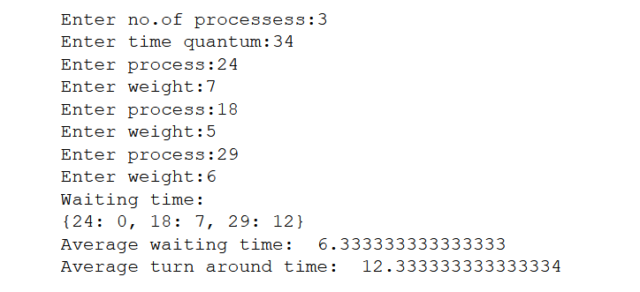

**Shortest Job First**

n = int (input("Enter no.of processess:"))

p = []

w = []

tw = 0

for i in range(n):

p.append(int (input("Enter process:")))

w.append(int (input("Enter weight:")))

small = 9999

d1 = dict(zip(p,w))

d2 = dict()

for i in range(n):

small = 9999

for j in d1.keys():

if(d1[j] < small):

small = d1[j]

t = j

d1[t] = 9999

d2[t] = small

d1 = d2

d2 = 0

print(d1)

weight = 0

print("Waiting time:")

for i, j in d1.items():

print (i,"=",weight)

d2 = d2 + weight

weight = weight + j

print("Average waiting time: ",d2/n)

for i in d1.values():

tw = tw + i

print("Average turn around time: ",(d2+tw)/n)

**Output:**

